Stool Transport Containers
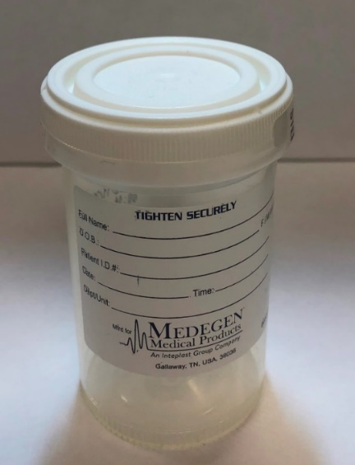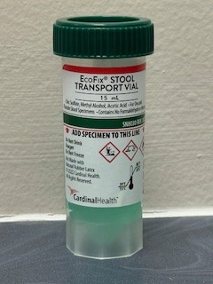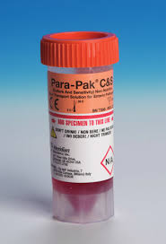
Plain container: Green EcoFix container: Orange Para-Pak C&S container:
Stool WBC Ova & Parasite (full exam) Bacterial/Viral Parasite Gastro PCR Panel
Stool WBC Bacterial/Viral Gastro PCR Panel
C. difficile (liquid stool only!) Bacterial Gastrointestinal PCR Panel
Calprotectin Giardia/Cryptosporidium Antigen
Pancreatic Elastase H. pylori PCR
Fecal Lactoferrin Stool Culture
Fecal Fat
Stool Occult Blood (may also be submitted on occult blood cards)

Please consult the laboratory for transport container guidance for any stool test that is not listed on this reference.

Note the red circles that show the “Add specimen to this line” guides. Specimens that are grossly over- or under-filled will be rejected and require recollection.

Collection Instructions:
- Pass the specimen into a clean dry container. A hat may be used (any clean, dry plastic container is suitable).
  - Do not use toilet paper to collect the specimen (it may contain agents that are inhibitory to some fecal pathogens).
  - Do not allow the specimen to come into contact with toilet water.
  - Do not contaminate the specimen with urine.
- Immediately transfer the specimen from the clean dry container into the provided (plain, green, orange) containers.
  - Open the containers.
  - Use the spoon that is attached to the cap to transfer enough specimen to bring the liquid to the fill line for the green and orange vials. Place a small amount in the white topped container.
  - Do not overfill. Fill only to the fill line. Overfilled containers will not be accepted for testing.
- Securely close all containers. Leaking containers will not be accepted for testing.
- Fully label each container:
  - Full Patient Name (First and Last)
  - Date of Birth
  - Collection Date
  - Collection Time
- Hold the green and orange top containers at room temperature.
- Hold the plain container refrigerated.
- Transport to the laboratory within 96 hours at room temperature.

If only the plain container is submitted for testing, specimens must be processed at the laboratory within 2 hours of collection.
It is important that preservative transport containers are used to prevent test cancellation.

 Caution: Colored vials contain poisonous liquids. Keep out of the reach of children and pets. DO NOT DRINK.


Microbiology Laboratory
600 Roe Avenue, Elmira NY
(607) 737-4119

